SUPPLY AND DEMAND
INDIVIDUAL PROJECT
UNIT 3

Using a format of your choice, you will demonstrate your understanding of Supply and Demand and how it relates to your world, by answering three of the five major questions below if you are working individually, or all five if you are working in pairs. A list of possible formats you can use are provided. If you choose to present your learning in a different format, please consult with Mrs. Lightman before you begin. Expectations for each type of format will be further explained in class.

Poster
Infographic
Political Cartoon
Video
Infographic Animation
‘Podcast’

There are a number of free online infographic poster and animation editors, which you can use to make your projects. Here are a few examples:
https://www.canva.com/create/infographics/
https://venngage.com/
https://biteable.com/infographic/

Content: Demand
- Using the vocabulary provided below, explain what you know about Demand. Use a product of your choice to prove the law of Demand and provide determinants that would increase or decrease the demand for that product. Include a graph to demonstrate your knowledge of demand and how shifts in demand would be illustrated. Use a unique product that is specific to your life!

Demand, Law of Demand, Price, Quantity Demanded, Determinants of Demand, Normal Goods, Inferior Goods, Substitute Goods, Complimentary Goods

Content: Supply
- Using the vocabulary provided below, explain what you know about Supply. Use a different product from your Demand example to prove the law of Supply and provide determinants that would increase or decrease the supply for that product. Include a graph to demonstrate your knowledge of supply and how shifts in shifts would be illustrated. Use a unique product that is specific to your life!

Supply, Law of Supply, Price, Quantity Supplied, Determinants of Supply

Content: Equilibrium
- Answer all of the following questions related to equilibrium
  - Using another product/industry of your choice, explain what it means when the market is in Equilibrium.
  - What does it mean when the market is out of Equilibrium? How will it return to equilibrium?
  - If there were a surplus of your product, what methods could get rid of the surplus with AND without changing the price?
  - If there was a shortage of your product, what methods could be used to allocate those resources with AND without changing the price?
  - What happens to equilibrium when there is a shift in Demand? What happens when there is a shift in supply? (Make sure to provide a cause for that shift that is associated with your product example)

Price, Equilibrium Price, Quantity Traded, Equilibrium, Surplus, Shortage, Shift Right (increase), Shift Left (decrease), Allocation Mechanisms

Content: Price Controls
- Provide an example of either a price ceiling or a price floor. (Please do not use rent control or minimum wage as an example as this has already been discussed at length in class). Explain:
  - the purpose of having the price control
  - Is the price control set above or below the natural market price? Why? What does this tend to cause? Surplus? Shortage? Why?
  - To whom does the price control benefit? Name the advantages and disadvantages associated with having this price control.
  - What do you think about the price control?

Price Controls, Price Floor, Price Ceiling, Market Price, Surplus, Shortage

Content: Elasticity
- For this question, you will act as an inventor/entrepreneur and make up a new product that does not exist. What does it mean when a product is elastic versus inelastic? Using the determinants of Elasticity, explain whether or not your product is Elastic. Include a hypothetical Elasticity V value (along with the math) to also explain your product’s elasticity. Why is it important for you to understand Elasticity as an Entrepreneur? How could you make more revenue?

Elasticity, Inelastic, Unitary Elasticity, Perfect Elasticity, Perfect Inelasticity, Determinants of Demand, Revenue (**Show your understanding of how to solve Elasticity and how to use that number)

ASSESSMENT
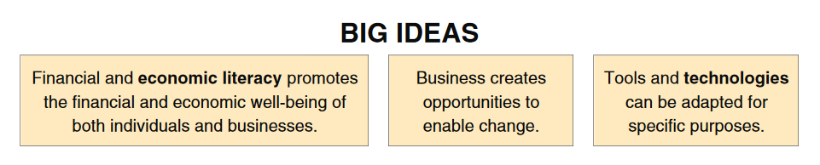
Through answering the above questions, you should know/understand:

Demand
Supply
Equilibirum
Price Controls
Consumer Choice and Elasticity
Economics in Everyday Life
Global Markets

Through answering the above questions, you should be able to:
Applied Design
- Conduct research to understand and explain economic concepts
- Choose or create various economic scenarios, and identify potential issues, intended impact, and possible unintended negative consequences
- Generate ideas, individually and collaboratively
- Identify patterns and trends to further understand economic systems
- Apply the appropriate tools to measure economic activity and impact (elasticity!!)
Applied Skills and Technology
- Communicate outcomes in multiple formats and in a clear and concise manner
- Identify and critically assess the skills needed related to current or projected tasks, and develop specific plans to learn or refine skills over time
- Explore existing, new, and emerging tools, technologies, and systems to further support facts and findings
- Evaluate impacts, including unintended negative consequences, of choices made about technology use

Project Deadline:
Block 2 & 4: Thursday January 31
Block 8: Friday February 1

